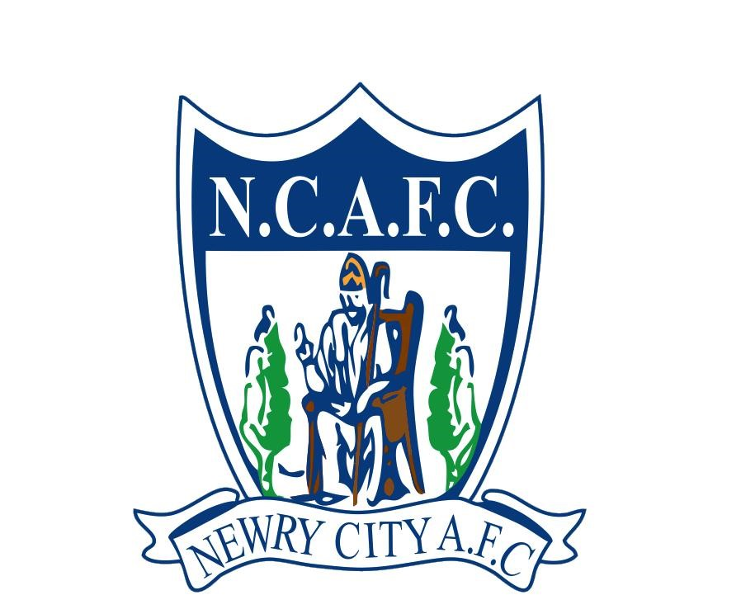
Newry City AFC
The Showgrounds
Greenbank Industrial Estate
Newry, Northern Ireland, BT34 2QF
W. www.newrycityafc.co.uk
E. info@newrycityafc.co.uk

Newry City AFC Academy Code of Conduct
This agreement ensures that both players and their families contribute to a respectful, supportive, and professional environment within the football academy.
As an academy player I agree to uphold the highest standards of behaviour on and off the field. This Code of Conduct outlines the principles that the club expects players to follow to maintain a positive and respectful environment within the academy.
Academy players are expected to:
- Treat all individuals with respect, demonstrating fair play and sportsmanship.
- Avoid negative behaviours such as foul language and aggressive conduct.
- Attend all training sessions, matches, and academy events punctually and advise coaches when I can’t.
- Act with integrity and honesty in all interactions.
- Report any unethical behaviour to academy staff.
- Support my teammates and foster a positive team environment.
- Communicate constructively with coaches and teammates.
- Always represent the academy positively, including on social media.
- Refrain from any behaviour that could tarnish the academy's reputation.
- Follow all health and safety guidelines provided by the academy.
- Balance academic and athletic responsibilities.
- Abstain from using any banned substances, including drugs and alcohol.
- Engage in academy-organised community initiatives.
- I will adhere to all academy rules and regulations.
- I will accept and respect decisions made by coaches, officials, and academy management.
By signing this code of conduct, I acknowledge that I have read, understood, and agree to abide by all the principles and rules outlined above, including the disciplinary process (available to download online) for breaches.
Player's Name: Date:

Signature:
Code of Conduct Agreement for Parents and Guardians
By signing this document, I commit to supporting my child's adherence to the academy's Code of Conduct and agree to demonstrate respect, sportsmanship, and positive behaviour always. I will support my child, their teammates and the coaches constructively, adhere to academy rules, communicate appropriately, and act as a positive role model. I understand that any misconduct may result in restricted access or exclusion from academy events, and I agree to abide by the academy's disciplinary process for breaches.
Parent / Guardian Name: Date:
Signature:

