Newry City AFC

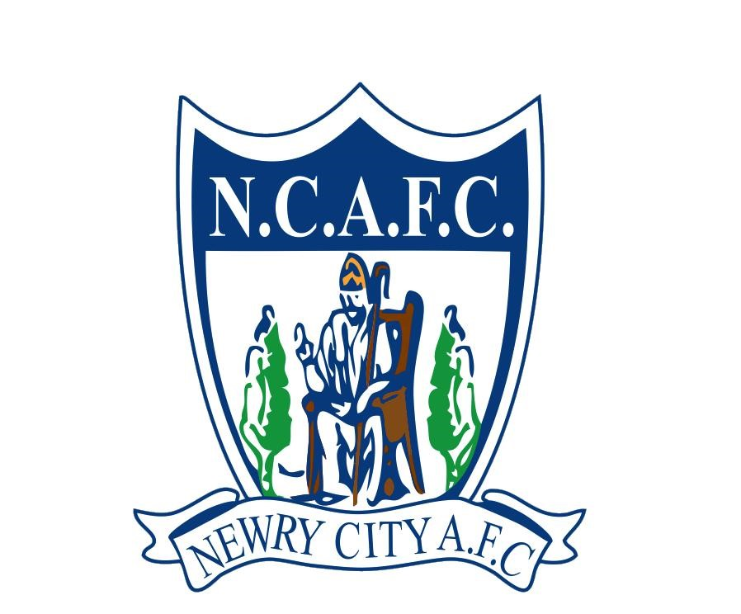

The Showgrounds

Greenbank Industrial Estate

Newry, Northern Ireland, BT34 2QF

**W**. [www.newrycityafc.co.uk](http://www.newrycityafc.co.uk)

**E**. info@newrycityafc.co.uk

**Newry City AFC Academy Disciplinary Process**

This document outlines the streamlined disciplinary process for academy players, parents, guardians, and coaches to ensure adherence to the Newry City AFC Academy Code of Conduct. The process maintains a respectful, supportive, and professional environment within the academy.

1. Reporting and Initial Review

Reporting: All instances of misconduct should be reported promptly:

Players report to academy staff.

Parents/guardians report to academy staff/management.

Coaches report to the designated disciplinary officer.

Initial Review: Academy staff conduct a preliminary review to verify the report, documenting the incident and informing relevant parties if substantiated.

2. Investigation

The academy disciplinary committee conducts a thorough investigation, which includes interviewing involved parties and reviewing evidence. The committee ensures confidentiality and fairness throughout the investigation process.

3. Disciplinary Meeting

A disciplinary meeting is held with the involved party to discuss the findings.

The involved party can present their perspective and any mitigating circumstances.

4. Decision and Communication

Based on the severity and nature of the misconduct, the committee decides on appropriate disciplinary actions, which may include:

Warning: Verbal or written.

Probation: Monitoring behaviour with conditions.

Suspension: Temporary removal from activities.

Expulsion: Permanent removal from the academy.

The decision is communicated in writing to the involved party and, if applicable, their parents or guardians, including the rationale and any conditions or expectations.

5. Appeal and Follow-Up

Appeal: The involved party may appeal the decision within seven days by submitting a written appeal to the academy director, detailing the grounds.

Follow-Up: The academy monitors compliance with disciplinary actions and provides support to ensure adherence. Continued breaches may result in escalated actions.

Adherence to the Newry City AFC Academy Code of Conduct is essential for fostering a positive and respectful environment. This disciplinary process ensures fair and consistent handling of breaches, promoting the values of respect, sportsmanship, and integrity within the academy community.