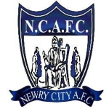

NCAFC Club Registration Form

Family name: _______________________________________________

First name: _________________________________________________

Nationality: _________________________________________________

Country of birth: ____________________________________________

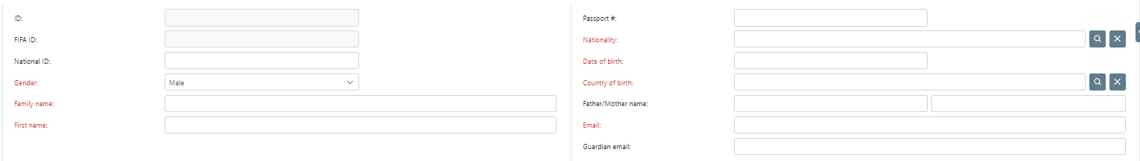
*Country of birth has to be accurate – if born in Daisy Hill for example COB must be Northern Ireland or the transfer system will flag for International Clearance.

Address: ____________________________________________________

Date of birth: _______________________________________________

Parent/Guardian full name: ___________________________________

Email: _____________________________________________________

Guardian email: _____________________________________________

Guardian contact number: _____________________________________

Previous club: ________________________________________________

Health Conditions: ____________________________________________

Signature: ____________________________________________________

Parent / Guardian signature if player U18: _________________________

Permission for photographs of player to be taken & used for promotion throughout the season:
______________________________________________________________

Please return a photo of completed form to laura@newrycityafc.co.uk or to your manager.

Please note when the registration is processed on Comet the club secretary will supply another document to be signed to verify consent of the registration.

