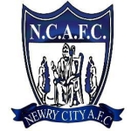

**Newry City AFC**

**Safeguarding Children and Young People in Football Policy**

gerrykeenan@newrycityafc.co.uk

patcraven@newrycityafc.co.uk

Gerard Hillen

gerhillen@msn.com

Pat Craven

Gerry Keenan

martin_mcloughlin@hotmail.com

Martin McLoughlin

Newry City Athletic Football Club